1. 
2. We saw how to make queries using Kibana’s Console Tool as it helps in a no of way.
   1. Format the response nicely.
   2. Set the content-type.
   3. Auto-completion.
   4. Etc.
3. Let’s see how to run query with CURL.
4. 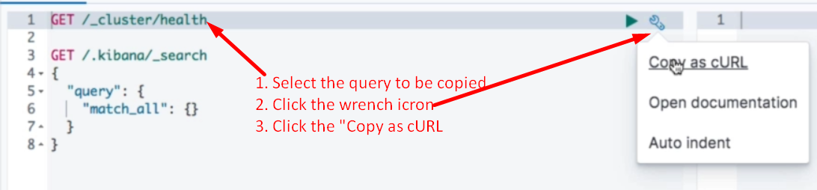
5. 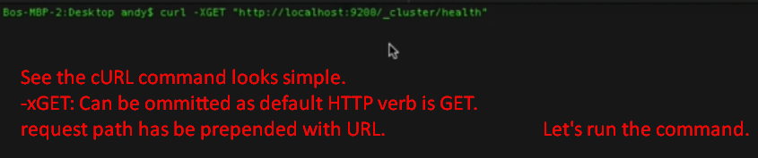
6. 
7. 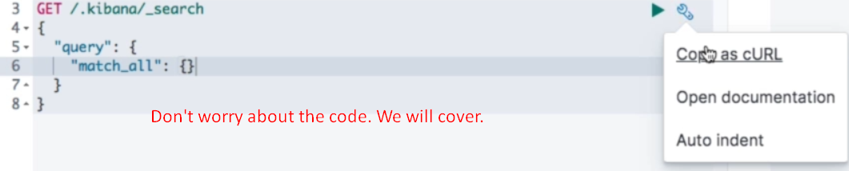
8. 
9. 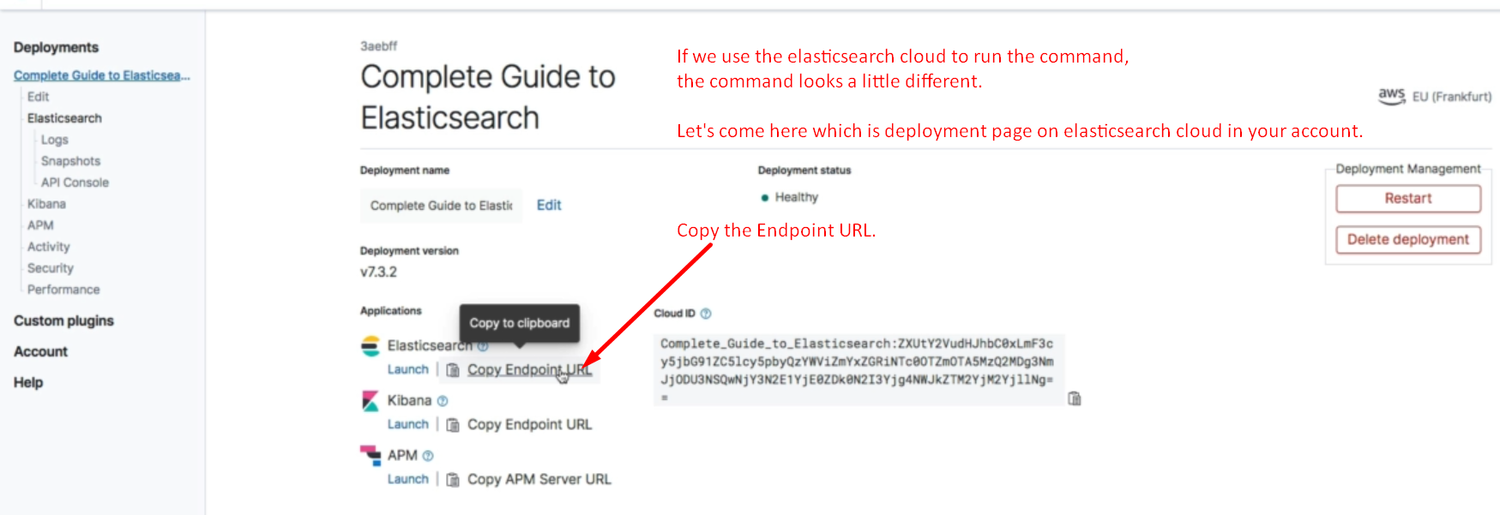
10. 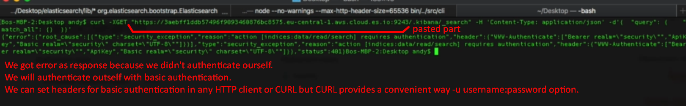
11. 